1. **Create a Database:**

* Create Table UserTBL (username varchar(50) , password(50) );
* Add few records to the tables (should be meaningful)

1. **Create a login form allow user to login.**

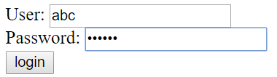

* User will be considered as authorized if they submit correct username and password defined in the database.
* User info then will be stored in session scope

1. **Define some Servlet pages:**
   * using url patterns : authen/servlet1, authen/servlet2,…
2. **Create a AuthenticationFilter to validate**
   * Check if user tries to access authen/* without login to the system. The system will navigate user to Login page.